* You'll need Java to run Jenkins (either method), so if your server doesn't yet have Java, install it with:

**sudo yum -y install java**

* In general, if you need a service or tool but you're not sure what package provides it, you can always check by running:

**yum whatprovides service**

**Installing from the Repo**

**sudo wget -O /etc/yum.repos.d/jenkins.repo** [**http://pkg.jenkins-ci.org/redhat/jenkins.repo**](http://pkg.jenkins-ci.org/redhat/jenkins.repo)

The wget tool downloads files into the filename specified after the "O" flag (that's a capital 'O', not a zero).

if you don’t have wget package you can download by using below

**yum install wget**

Then, import the verification key using the package manager RPM:

**sudo rpm --import** [**https://jenkins-ci.org/redhat/jenkins-ci.org.key**](https://jenkins-ci.org/redhat/jenkins-ci.org.key)

Finally, install Jenkins by running:

**sudo yum install jenkins**

That's it! You should now be able to start Jenkins as a service:

**sudo systemctl start jenkins.service**

Once the service has started, you can check its status:

**sudo systemctl status jenkins.service**

you should see two lines similar to the following:

**Loaded: loaded (/etc/rc.d/init.d/jenkins; bad; vendor preset: disabled)**

**Active: active (running) since Wed 2018-08-29 10:54:55 UTC; 11s ago**

This means that the Jenkins services completed its startup and is running. You can confirm this by visiting the web interface as before, at <http://ip-of-your-machine:8080>

We should see "Unlock Jenkins" screen, which displays the location of the initial password

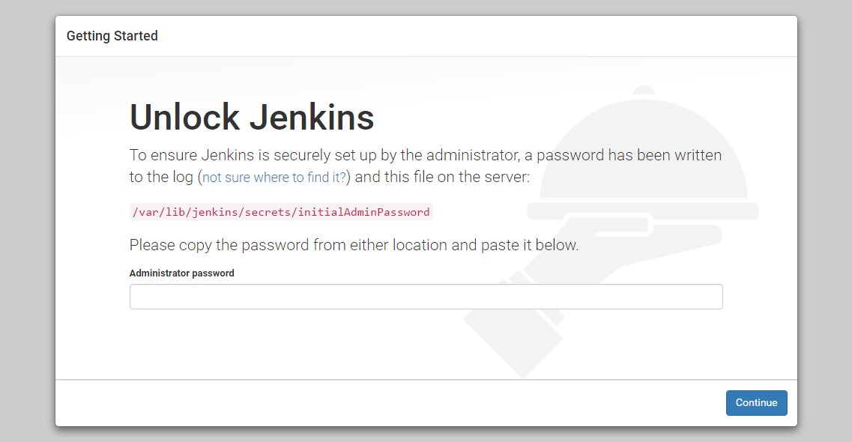

In the terminal window, we'll use the cat command to display the password:

**More xxxxxxxxxxxxx**

We'll copy the 32-character alphanumeric password from the terminal and paste it into the "Administrator password" field, then click "Continue". The next screen presents the option of installing suggested plugins or selecting specific plugins.

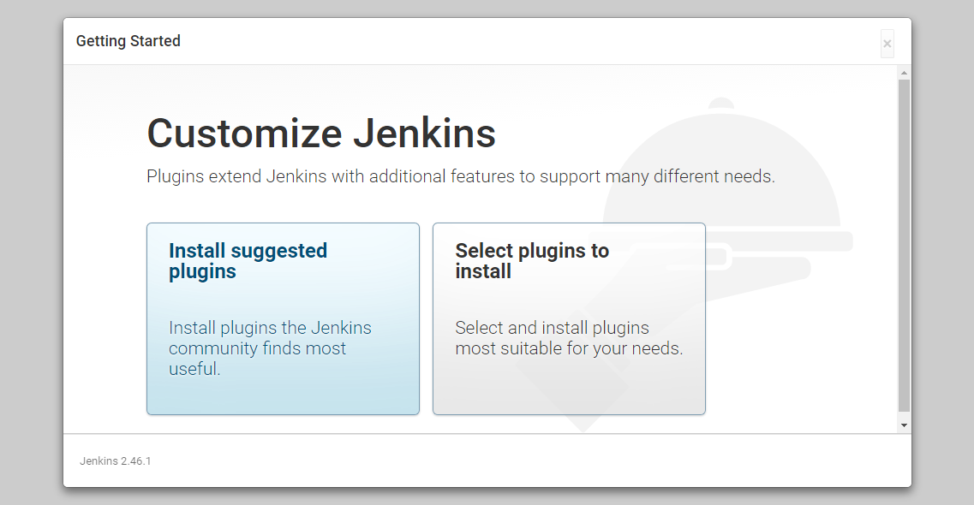

We'll click the "Install suggested plugins" option, which will immediately begin the installation process:

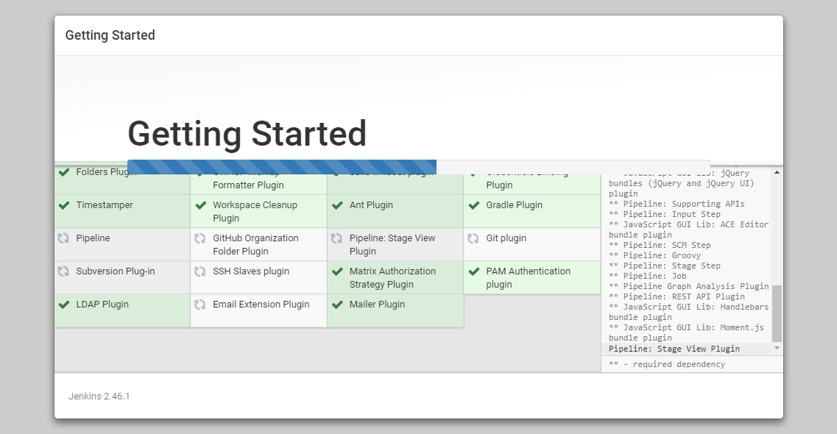

When the installation is complete, we'll be prompted to set up the first administrative user.

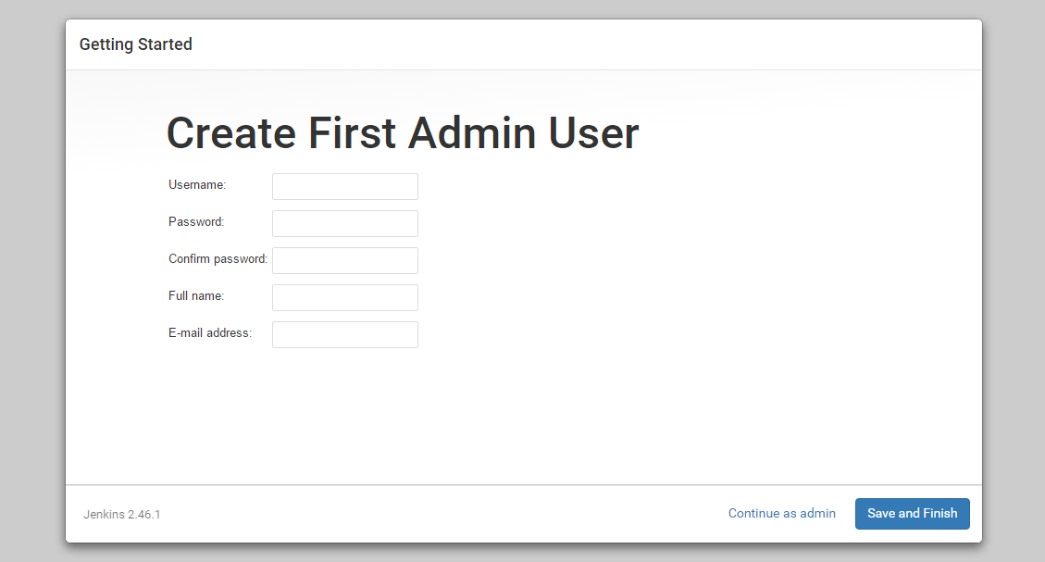

Once the first admin user is in place, you should see a "Jenkins is ready!" confirmation screen.

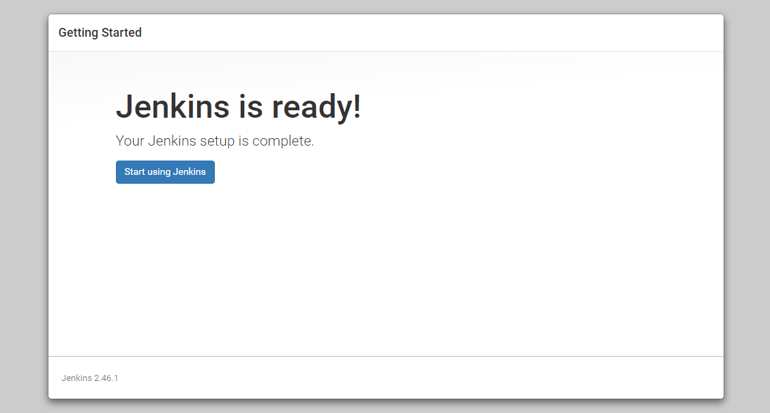

Click "Start using Jenkins" to visit the main Jenkins dashboard:

